Mark Stratan
Mr. Egan
SPH4UR
January 18, 2026

Physics Summative Report

Table of Contents
Table of Contents 1
Introduction and Design 2
Summary 2
Blueprints 2
Materials & Sustainability Impact 3
Analysis 4
Spring Calibration and Hooke's Law 4
Energy Conservation & Kinematics (Projectile Motion) 5
Momentum & Collisions 7

Introduction and Design

Summary
In this culminating project, we as a group have to design, build, and tweak a marble launcher using materials that are sustainable, have little to no impact on the environment. The built marble launcher will be used to hit 3 targets from a distance of 3.5 meters away. Then, using physics concepts, we are to analyze the different parts of the marble launch, firing and collision with the target, and demonstrate a strong understanding of springs, Hooke's Law, energy conservation, kinematics, momentum, and collisions.

Blueprints
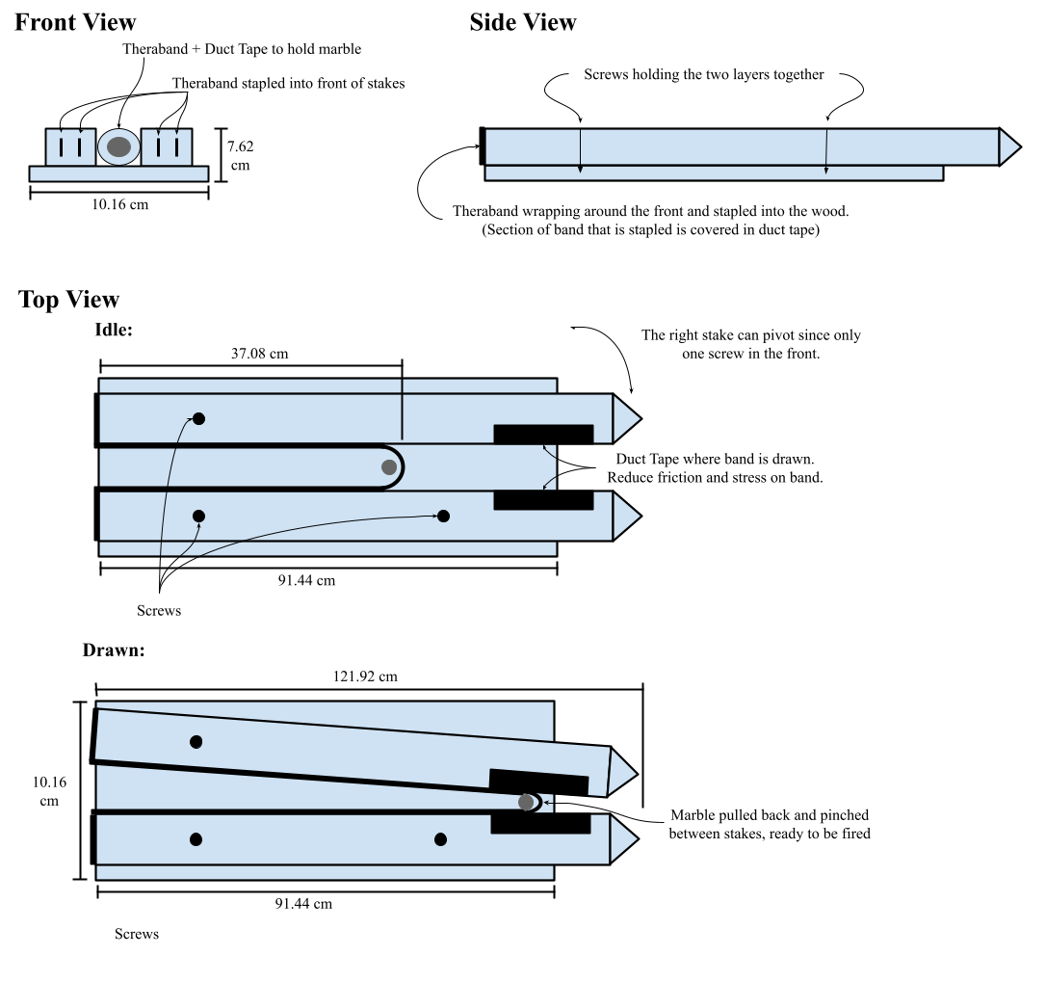

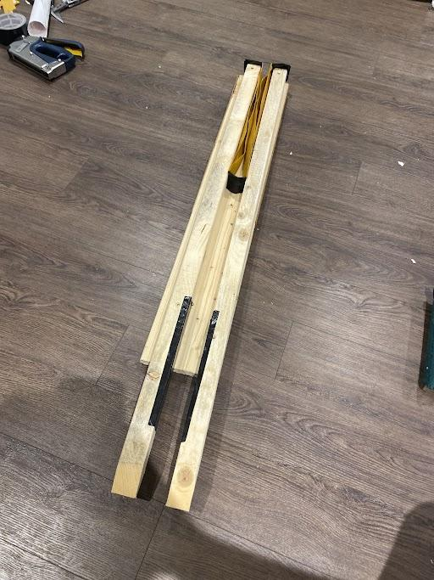

Materials & Sustainability Impact
- 1 sheet of wood (1x4x36”) & 2 wooden stakes (2x2x48”)
Wood is a sustainable resource that can be found in most homes. Its sustainability due to it being biodegradable, which leads to no environmental footprint. Trees are a renewable resource over long periods of time.

- 1 “theraband” elastic band
The elastic band is a sustainable resource that can be found in some homes. It is sustainable and renewable if produced from natural latex, but if it is from synthetic latex it is not sustainable and is non-renewable. Natural latex is biodegradable over long periods of time, but synthetic latex is not.

- Duct tape
- Duct tape is not a sustainable resource, but can usually be found in homes. It is not sustainable and non-renewable due to the resources used to produce it leaving a high environmental footprint. On top of that, these resources make duct tape not recyclable and not biodegradable.

- Staples (construction) & 3 screws
- Staples and screws are sustainable resources that can be found in most homes. It is non-renewable due to the finite amount of iron available on earth, but sustainable due to it being 100% recyclable.

Analysis

Spring Calibration and Hooke's Law
In our project we decided to use rubber bands to propel the marble, rather than a spring. The rubber bands were more readily available for this project in our households.

Hooke’s law describes the proportional relationship between applied force and stretch. For a spring this behaviour is linear, but for rubber bands it is non-linear and does not perfectly obey Hooke’s Law. In a stretch to force graph, the stretch is not directly proportional meaning there might be a decreasing or increasing slope, emphasizing that rubber bands do not always follow a perfectly straight line on a graph.

For the k constant calculations, we were unsure if the ballistic pendulum that I constructed would be usable. We decided to use velocity to calculate the k constant by measuring the time the marble took to travel a certain distance. Using the velocity, we would apply E_{Tot A} = E_{Tot B} to calculate the k constant using $Δx$ and the Kinetic Energy.

Calculating Velocity
To calculate velocity, we used a high speed camera, also known as slow motion video, to record and measure the time the marble took to travel a set distance of 2.1 meters. We repeated this process 5 times.

Trial | 1 | 2 | 3 | 4 | 5 | Average
Time | 0.067 | 0.07 | 0.075 | 0.063 | 0.06 | 0.067

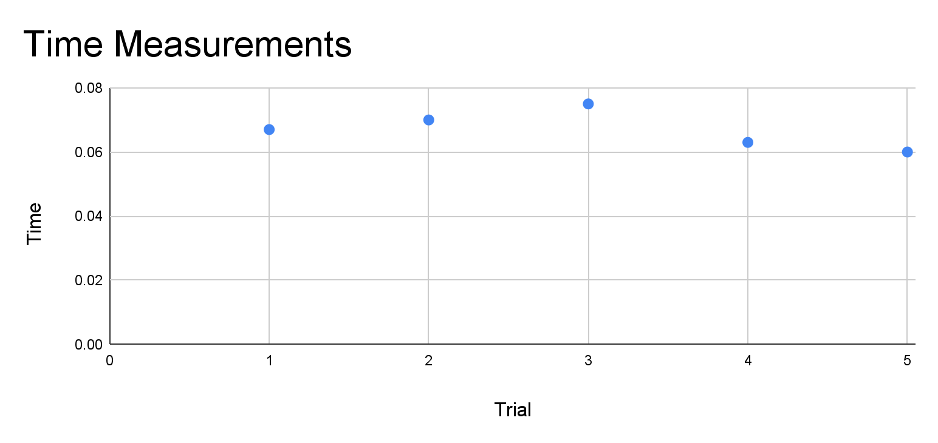
Average Time: $\frac{0.067 + 0.07 + 0.075 + 0.063 + 0.06}{5} = 0.067$ s
v$= \frac{Δd}{Δt}$
v$= \frac{(2.1)}{(0.067)}$
v$≈$31.39 m/s

Calculating k constant
E_{Tot A} = E_{Tot B}
$\frac{1}{2}kΔx$²$=$$\frac{1}{2}mv$²
$k = \frac{mv{}^{2}}{Δx{}^{2}}$
$k = \frac{(0.003)(31.39){}^{2}}{(0.37){}^{2}}$
$k ≈$21.59 $\frac{N}{m}$

Energy Conservation & Kinematics (Projectile Motion)
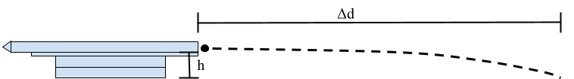

- Kinematics Equation Conversion
To calculate how much the rubber band needs to extend, we first need to know how long the marble will take to hit the ground. To determine this we take the the kinematics equation: $Δd$_{y}$= v$_{iy}$Δt+\frac{1}{2}aΔt$² and adjust the variables to suit what we need. We first replace $Δd$_{y} with height (h) since the ball will be falling from that height to the ground for the case where the target is on the ground, and set the initial vertical velocity ($v$_{iy}) to 0 since it originally is moving in the horizontal direction. We then replace acceleration with g, the acceleration due to gravity since it will continuously fall to the ground until it reaches it, and finally make the entire equation equal to time ($Δt$) to find out how long it will be in the air
$Δd$_{y}$= v$_{iy}$Δt+\frac{1}{2}aΔt$²
h$= (0)$$Δt+\frac{1}{2}gΔt$² ⇒ h$=$$\frac{1}{2}gΔt$²
$Δt$$=$$\sqrt{\frac{2h}{g}}$ (1)

- Implementing Converted Kinematics Equation into Velocity Equation
Now that we have the formula on how long the marble would be in the air, we can then use it to formulate the equation for the required velocity. We substitute $Δt$ in the velocity equation with the time formula (1) above. Since we will need $v$_{x}² in the energy equation, we can simplify the formula by squaring the entire equation. By doing this we can remove the square root.

$v$_{x}$=$$\frac{Δd}{Δt}$ ⇒ $v$_{x}$=$$\frac{Δd}{\sqrt{\frac{2h}{g}}}$
$v$_{x}²$=$($\frac{Δd}{\sqrt{\frac{2h}{g}}}$)²
$v$_{x}²$=$$\frac{Δd{}^{2}}{(\frac{2h}{g})}$
$v$_{x}²$=$$\frac{gΔd{}^{2}}{2h}$ (2)

- Covert Kinetic Energy Equation & Implement Velocity Equation
Now that we have the velocity equation (2) on how fast the marble needs to fly, we can finally calculate how much the rubber band needs to extend to make the marble fly the required distance. To do this we first take the equation: E_{Tot A}$=$E_{Tot B} and use it to calculate the energy input based on the required energy output, in an ideal situation. We then set the energy input to be the spring energy equation and the energy output to be the kinetic energy equation. We finally extract the rubber band extension ($Δx$) from the equation and substitute the velocity ($v$_{x}²) with the equation derived above (2).
E_{Tot A}$=$E_{Tot B}
$\frac{1}{2}kΔx$²$=$$\frac{1}{2}mv$_{x}²
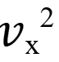
$Δx$$=$$\sqrt{\frac{m }{k}}$
$Δx$$=$$\sqrt{\frac{m(\frac{gΔd{}^{2}}{2h})}{k}}$
$Δx$$=$$\sqrt{\frac{mgΔd{}^{2}}{2hk}}$ (3)

- Calculating Spring Extension Required ($Δx$)
Now that we have one final equation (3), we can finally find the required rubber band extension required using the variables listed below:
- Mass of marble: m = 0.003 kg
- The k-value: k = 21.59 $\frac{N}{m}$
- The starting height is: h = 0.12 m
- Acceleration due to gravity: g = 9.81 m/s²
- Distance to the target: $Δd$ = 3.5 m
The formula (3): $Δx$$=$$\sqrt{\frac{mgΔd{}^{2}}{2hk}}$
Substituting variables with above values: $Δx$$=$$\sqrt{\frac{(0.003)(9.81)(3.5){}^{2}}{2(0.12)(21.59)}}$
$Δx$$=$$0.2638$
$Δx$$≈$$0.264$ m$≈$ $26.4$ cm

To cover 3.5 meters of distance from a height of 12 cm, the extension of the rubber should be at least 26.4 cm.

Momentum & Collisions
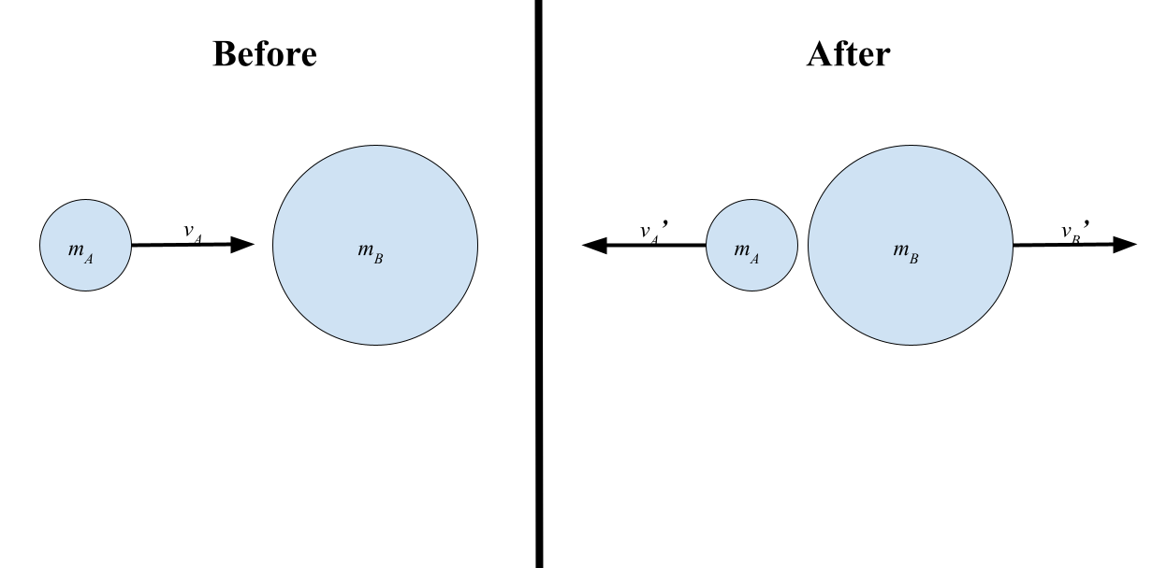
When calculating the speed of object A and object B after an elastic collision, we use the momentum and kinetic energy formula to achieve this due to the presence of two missing variables. The other variables that are known to us are as listed below:
- m_{A} = 0.003 kg
- m_{B} = 0.06 kg
- v_{A} = 31.39 m/s [forward]
- v_{B} = 0 m/s

- Elastic Collision: Conservation of Momentum Formula
In an ideal elastic collision, the momentum before the collision is equal to the momentum after the collision. This leads us to an equation: m_{A}v_{A} + m_{B}v_{B}$=$m_{A}v_{A}’ + m_{B}v_{B}’ that has two unknown variables. The best action is to rearrange the equation such that it is equal to one of the unknown variables and then substitute variables with numbers of those we know. This leaves us with a linear equation that will be useful to us later.
p_{Tot}$=$p_{Tot}’
m_{A}v_{A} + m_{B}v_{B}$=$m_{A}v_{A}’ + m_{B}v_{B}’
m_{A}v_{A}$=$m_{A}v_{A}’ + m_{B}v_{B}’ ⇒ m_{A}v_{A}’$=$m_{A}v_{A} – m_{B}v_{B}’
v_{A}’$=$v_{A} – $\frac{m{}_{B}^{}}{m{}_{A}^{}}v$_{B}’

- Elastic Collision: Conservation of Kinetic Energy Formula
In an ideal elastic collision, no energy is lost or transformed into other forms of energy such that the total kinetic energy input is equal to the total kinetic energy output. This leads to the equation: $\frac{1}{2}$m_{A}v_{A}² + $\frac{1}{2}$m_{B}v_{B}²$=$$\frac{1}{2}$m_{A}v_{A}’ ² + $\frac{1}{2}$m_{B}v_{B}’ ² that also has two unknowns as the one above. This leads us to simplify the equation by substituting the variables with values, to later allow us to implement the equation above into the equation below.
KE_{Tot}$=$KE_{Tot}’
$\frac{1}{2}$m_{A}v_{A}² + $\frac{1}{2}$m_{B}v_{B}²$=$$\frac{1}{2}$m_{A}v_{A}’ ² + $\frac{1}{2}$m_{B}v_{B}’ ²
m_{A}v_{A}²$=$m_{A}v_{A}’ ² + m_{B}v_{B}’ ²
v_{A}²$=$v_{A}’ ² + $\frac{m{}_{B}^{}}{m{}_{A}^{}}v$_{B}’ ²

- Implementing Momentum Formula into Kinetic Energy Formula to Calculate v_{B}’ & v_{A}’
Now we can use both the momentum and kinetic energy formulas to calculate both unknown variables by substituting the momentum formula into the kinetic energy formula. By doing so we are left with a quadratic equation where we can use the quadratic formula to solve for one of the variables. After calculating the first unknown variable we can then use it to calculate the second variable using the momentum formula allowing us to find out at what speed the two objects move at after the ideal elastic collision.
v_{A}²$=$v_{A}’ ² + $\frac{m{}_{B}^{}}{m{}_{A}^{}}v$_{B}’ ²
v_{A}²$=$(v_{A} – $\frac{m{}_{B}^{}}{m{}_{A}^{}}v$_{B}’ )² + $\frac{m{}_{B}^{}}{m{}_{A}^{}}v$_{B}’ ²
0$=$(v_{A} – $\frac{m{}_{B}^{}}{m{}_{A}^{}}v$_{B}’ )² + $\frac{m{}_{B}^{}}{m{}_{A}^{}}v$_{B}’ ² – v_{A}²
This quadratic equation has only one unknown variable v_{B}’, and we can calculate it by using the quadratic formula.
0$=$[(31.39) – $\frac{(0.06)}{(0.003)}v$_{B}’ ]² + $\frac{(0.06)}{(0.003)}v$_{B}’ ² – (31.39)²
0$=$[(31.39) – $20v$_{B}’ ]² + $20v$_{B}’ ² – 985.3321
0$=$[985.3321 – 1255.6v_{B}’ + 400v_{B}’ ²] + 20v_{B}’ ² – 985.3321
0$=$420v_{B}’ ² – 1255.6v_{B}’

Quadratic Formula:
v_{B}’$= \frac{-(-1255.6) ± \sqrt{(-1255.6){}^{2} - 4(420)(0)}}{2(420)} = \frac{1255.6 ± 1255.6}{840}$
v_{B}’₁$= \frac{1255.6 + 1255.6}{840} =$2.9895$≈$3 m/s
v_{B}’₂$= \frac{1255.6 - 1255.6}{840} = 0$
v_{B}’$≈$3 m/s [forward]

v_{A}’$=$31.39 – 20v_{B}’
v_{A}’$=$31.39 – 20(3)
v_{A}’$=$– 28.61 m/s [forward] $=$28.61 m/s [backward]

After the ideal elastic collision, object B starts moving forward at a speed of 3 m/s while object A recoils from the collision and starts moving backwards 28.61 m/s.

